影像處理作業-HW4

學生：林正浩 學號：r11631029 日期：11/05

1. 介面介紹：

Part1主要就是「FFT and IFFT」的按鈕。

Part2就是按鈕「ideal Low」~「butterworth High」根據輸入欄位D0的數值去做變化。＊D0一定要有數值。

Part3為按鈕「homomorphic」根據輸入「gammaH, gammaL, D0」去進行運算。

Part4為最下面兩的按鈕，差別主要為是否有加入隨機雜訊。

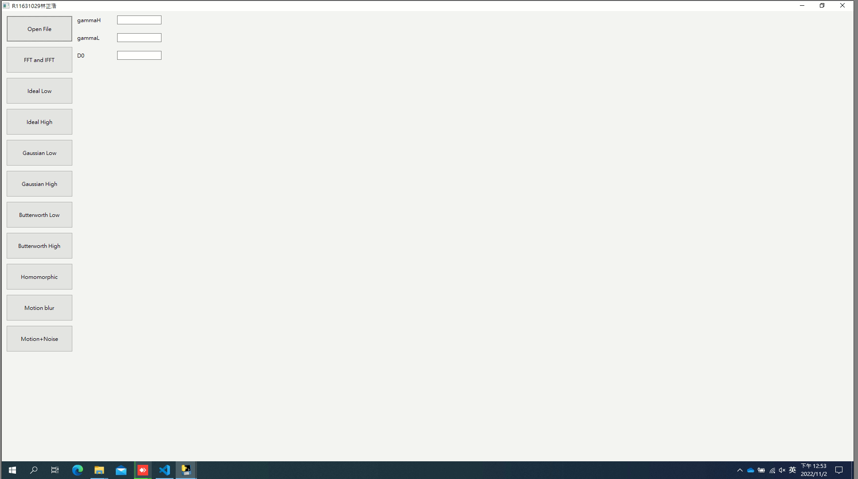

1. Part1 傅立葉轉換及傅立葉反轉換

傅立葉轉換code:

Step: 轉換🡪平移🡪計算spectrum and phase angle

def FT(Gray_img):

f = np.fft.fft2(Gray_img) # fourier transform

f_shift = np.fft.fftshift(f) # shift origin point

magnitude_spectrum = 20 * np.log(1 + np.abs(f_shift)) # show specturm photo

phase_angle = np.angle(f_shift) # show phase angle fig

return f_shift, magnitude_spectrum, phase_angle # 平移後的fourier transform, 頻譜圖, 相角圖

傅立葉反轉換code:

def FIT(sample_after_FT):

f_ishift = np.fft.ifftshift(sample_after_FT) # shift again for one shift when has run FT.

img_back = np.fft.ifft2(f_ishift) # fourier inverse transform

img_back = np.abs(img_back) # show image of FIT

return img_back # fourier 逆轉換後的照片

運行結果：

發現使用numpy本身的傅立葉轉換跟反傅立葉後與原圖雖然肉眼看不出差異，但仍是有差異存在。

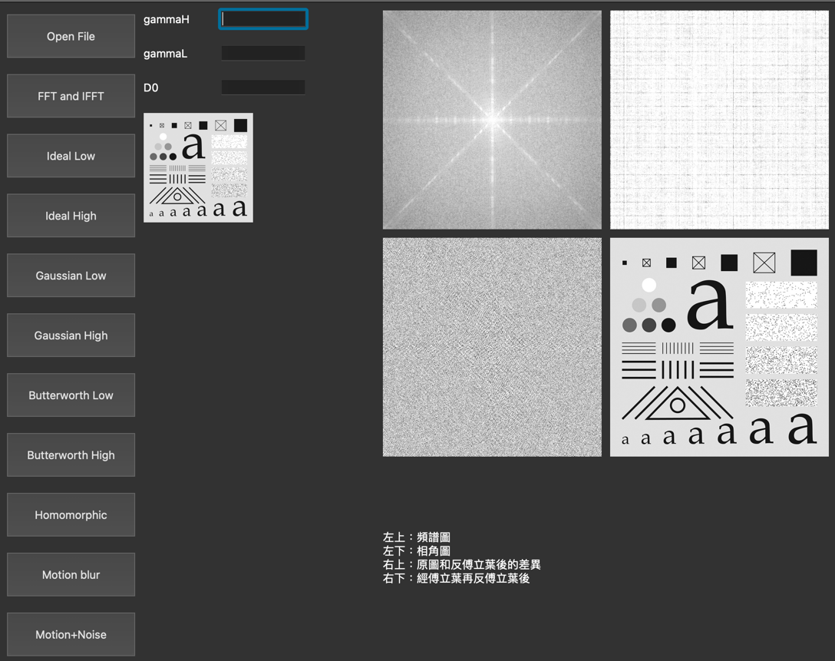

使用兩張不同size的照片進行：

256*256需要：0.00776600837707519 s

512*512需要：0.03227710723876953 s

時間差大約4~5倍。

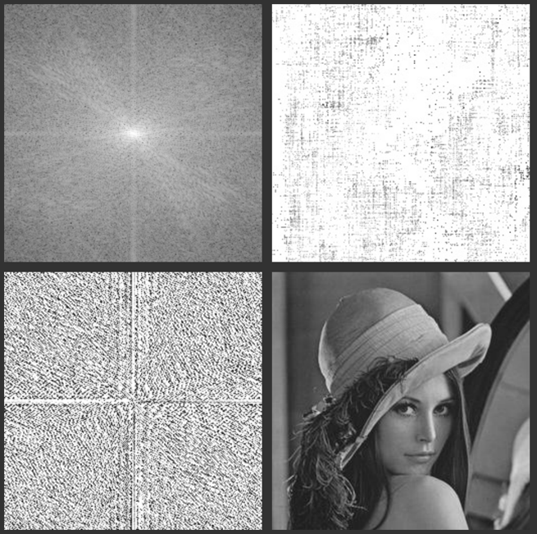 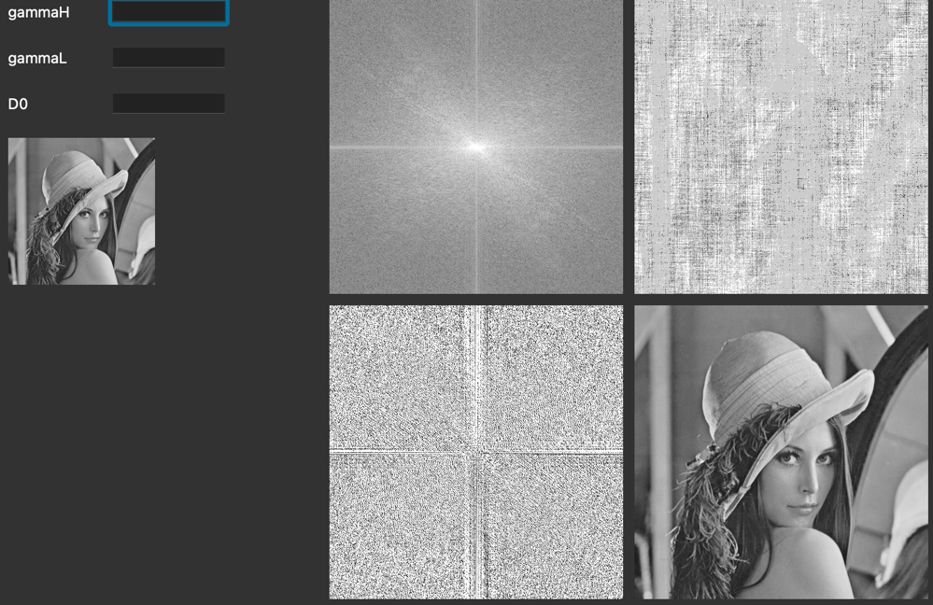

1. Part2 highpass and lowpass mask
2. Ideal filter:

# ideal_pass(gray_img, radius, Low or High)

def ideal_Pass(img_gray, radius, Type): # ideal Lowpass, 設定一個頻率域的threshhold, 去進行保留或去除

# set parameter

h, w = img_gray.shape

center_X = h/2

center_Y = w/2

R = radius

# Fourier Transform

fft_Shift, magnitude_spectrum, phase_angle = FT(img_gray)

# Run ideal pass --> classify Low or High

if (Type == 'Low'):

for i in range(h):

for j in range(w):

if ((i - center_X)**2 + (j - center_Y)**2 > R**2):

fft_Shift[i, j] = 0

else:

for i in range(h):

for j in range(w):

if ((i - center_X)**2 + (j - center_Y)**2 < R**2):

fft_Shift[i, j] = 0

# Fourier inverse transform

img = FIT(fft_Shift)

# spectrum

specturm = 20 * np.log(1 + np.abs(fft_Shift))

return img, specturm

1. Gaussian filter:

def gaussian_pass(img_gray, D0, Type):

# set parameter

h, w = img_gray.shape

center_X = h/2

center_Y = w/2

# Fourier Transform

fft_Shift, magnitude_spectrum, phase_angle = FT(img_gray)

# Run gaussian pass --> classify Low or High

if (Type == 'Low'):

val, direct = (0, 1)

else:

val, direct = (1, -1)

for i in range(h):

for j in range(w):

fft_Shift[i, j] = fft_Shift[i, j] * (val + direct * (np.exp(-((i - center_X)**2 + (j - center_Y)**2) / (2 * (D0**2)))))

# Fourier inverse transform

img = FIT(fft_Shift)

# spectrum

specturm = 20 * np.log(1 + np.abs(fft_Shift))

return img, specturm

1. Butterworth filter:

def butterworth_pass(img_gray, D0, n, Type):

# set parameter

h, w = img_gray.shape

center_X = h/2

center_Y = w/2

# Fourier Transform

fft_Shift, magnitude_spectrum, phase_angle = FT(img_gray)

# Run gaussian pass --> classify Low or High

if (Type == 'Low'):

val, direct = (0, 1)

else:

val, direct = (1, -1)

for i in range(h):

for j in range(w):

fft_Shift[i, j] = fft_Shift[i, j] * (val + direct * (1 / (1 + (((i - center_X)**2 + (j - center_Y)**2) / D0)**n)))

# Fourier inverse transform

img = FIT(fft_Shift)

# spectrum

specturm = 20 * np.log(1 + np.abs(fft_Shift))

return img, specturm

根據課本及上課講義上的formular去調整每一個filter的算法。因為圖片眾多，故選擇用高斯作為報告例子。

D0為頻譜的半徑長度，發現當D0越小時，高斯低通濾波越強烈。由左至右是D0=10,30,60。

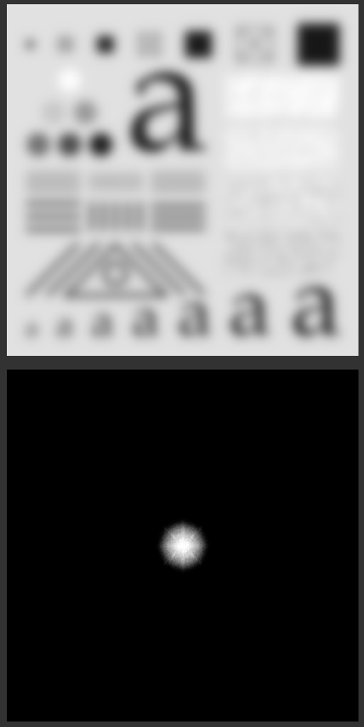 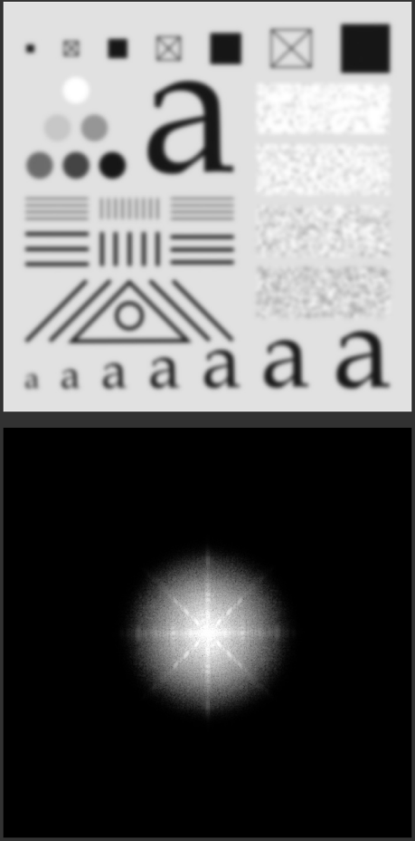 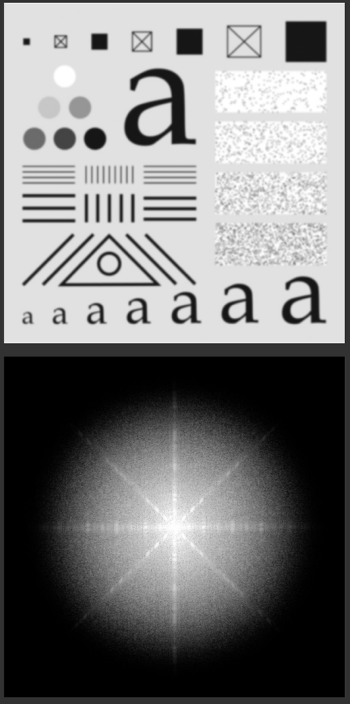

1. Part3 Homomorphic filter

def homomorphic(img_gray, gammaH, gammaL, D0, c):

img_gray = np.log(img_gray) # get ln() for fig. 4.58

h, w = img_gray.shape

center_X = h/2

center_Y = w/2

# Fourier Transform

fft_Shift, magnitude_spectrum, phase_angle = FT(img_gray)

# run homomorphic --> reference: https://www.twblogs.net/a/5bca7d8d2b71777351979e58

for i in range(h):

for j in range(w):

fft_Shift[i, j] = fft_Shift[i, j] * ((gammaH - gammaL) * (1 - np.exp(-c * ((i - center_X)**2 + (j - center_Y)**2) / D0**2)) + gammaL) # formular: 4-147

# Fourier inverse transform

img = FIT(fft_Shift)

img = np.exp(img) # get exp() for fig. 4.58

# spectrum

specturm = 20 * np.log(1 + np.abs(fft_Shift))

return img, specturm

根據課本內容， gammaL<1，gammaH>=1，能提升對比，達到會銳化效果。

GammaH = 2, gammaL = 0.2, D0 = 60

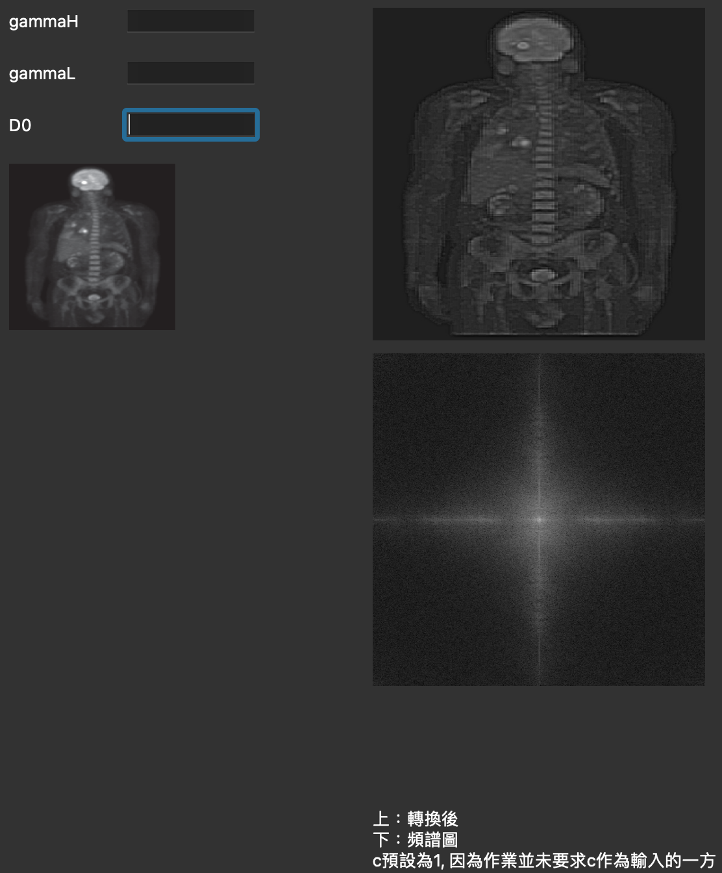

GammaH = 2, gammaL = 0.2, D0 = 10

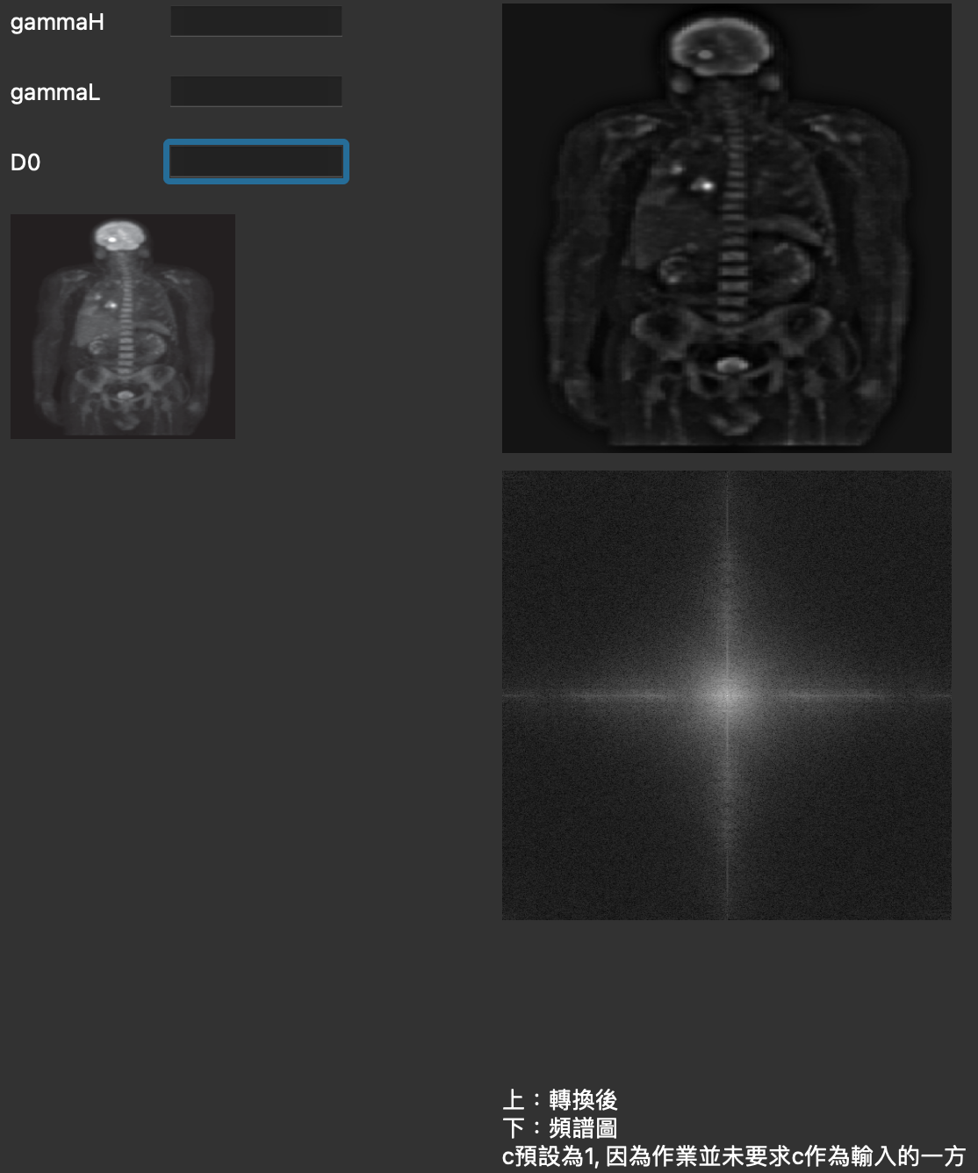

1. Part4 修復移動模糊及隨機雜訊

根據課本公式將算法寫入for迴圈。

# motion blur

def motion_blured(img_gray, addNoise, T, a, b, K):

# Motion blur parameters

# addNoise: 1--> yes, 0 --> no

# T: duration of exposure

# a: vertical motion

# b: horizontal motion

# K: the wiener parameter, small is better

# FT

fft_Shift, magnitude_spectrum, phase_angle = FT(img_gray)

#-----Creat array H(u, v) "start"-----#

# H(u, v), motion blur function in frequency domain

# Create matrix H (motion blur function H(u, v))

M,N = fft_Shift.shape

H = np.zeros((M + 1, N + 1), dtype = np.complex128) # +1 to avoid zero division

# Fill matrix H

for u in range(1, M + 1):

for v in range(1, N + 1):

w = np.pi * (u * a + v * b)

H[u, v] = (T / w) * np.sin(w) * np.exp(-1j * w) # formular 5-77

# index slicing

H = H[1 : , 1 : ]

#-----Creat array H(u, v) "end"-----#

# add noise

if addNoise == 1:

# G(u, v), blurred image in frequency domain

G = H * fft_Shift

# Fourier inverse transform

img = FIT(G)

# creat noise matrix

mean = 0

variance = 20 # 題目設定

noise = np.random.normal(mean, variance, img.size)

noise = noise.reshape(img.shape[0], img.shape[1]).astype('uint8')

img = img * noise

G, magnitude_spectrum, phase_angle = FT(img)

else:

# G(u, v), blurred image in frequency domain

G = H * fft_Shift

# Fourier inverse transform

img = FIT(G)

# do inverse filter

# according to formular 5-78

F_inverse = G / H

img_after_inverse = FIT(F_inverse)

# do wiener filter

# according to formular 5-85

# K = 0.0001

F_wiener = (1 / H) * (np.abs(H)**2 / (np.abs(H)**2 + K)) * G

img_after_wiener = FIT(F_wiener)

# compare with inverse and wiener

img_compare = img_after_inverse - img_after_wiener

return img, img_after_inverse, img_after_wiener

由下方結果可見，產生的效果與課本有所出入，相同的點是有產生殘影跟模糊。對於只有移動模糊的照片而言，inverse效果比wiener好很多，但我想這是應該的，因為我們本來就知道真正的Ｈ（u, v），當wiener的Ｋ=0時其實就是inverse，也就是說K🡪0效果會越好。

討論一下有移動跟雜訊模糊的照片，發現wiener效果好很多。上網搜尋一番也都表明，wiener對於噪點的處理比較好。

